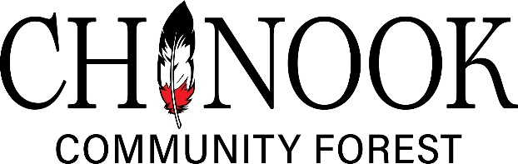

December 9, 2025 Public Record of Meeting – 9:00 A.M. BLNDC Board Room

PRESENT

OLD BUSINESS
The K4R

NEW BUSINESS
The YTD financials were presented to the board.

The
CORRESPONDENCE
A

DONATION COMMITTEE
Awarded $4,200 in donations to five community organizations: All Clans

GENERAL MANAGER’S REPORT
- Harvesting

Shannon Haizimsque, President
Wet’suwet’en Representative

Rilla Middleton, Vice President
RDBN – Area B Representative

Paul Davidson, Secretary
Village of Burns Lake Representative

Kieran Broderick, Treasurer
Nee Tahi Buhn Nation Representative

Greg Hill, Director
RDBN Area E Representative

Duane Crouse
Lake Babine Nation Representative

Ben Wilson
Cheslatta Carrier Nation Representative

Skin Tyee Representative vacant
Ken Nielsen, General Manager

Valerie Anderson
Executive Assistant/Accounting

The meeting adjourned at 10:14 a.m.
Next meeting: December 9, 2025, at 10:00 am

______________________________________

Shannon Haizimsque, President

____________________________________
Ken Nielsen, General Manager

